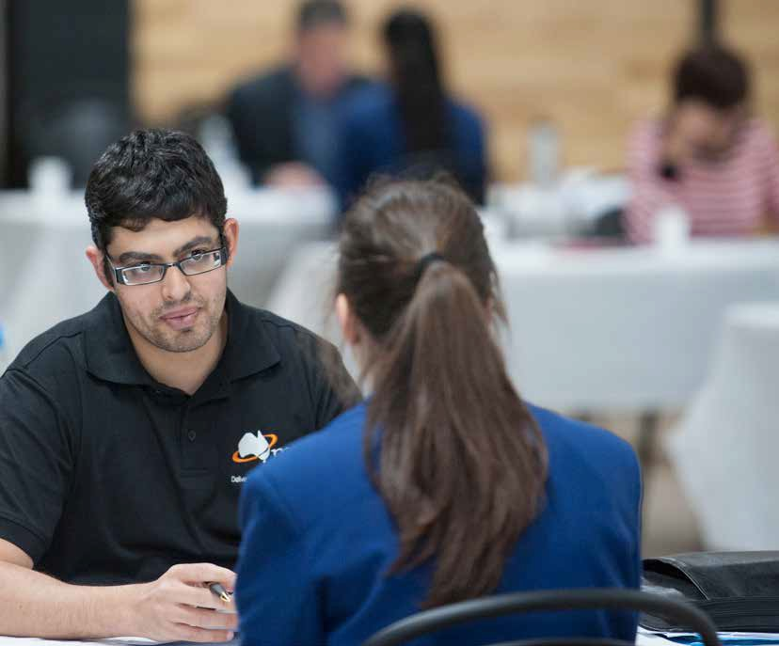PREPARING FOR AN INTERVIEW (SESSION 2)

TOPICS
Interview etiquette
Managing stress in an interview Interview questions
Practise interview with peers Using S.O.A responses Interview evaluation form

LEARNING INTENTION
The learner understands the questions and employerm expectations, and is able to practise their interview skills.

This lesson may be co-delivered with an industry partner

LESSON 6:
PREPARING FOR AN
INTERVIEW (SESSION 2)

FOCUS
Interview etiquette expectations, how to manage stress and practising answers to commonly asked interview questions.

STUDENT OUTCOMES
- Understanding of appropriate etiquette for an interview
- Knowledge of techniques to handle stress during an interview
- Ability to perform a mock interview and answer commonly asked interview questions

OUTLINE

Interview etiquette
Open a discussion about interview etiquette supported by the handout on page 50.

Managing stress in an interview
Open a discussion about how stress can affect us with job interviews.
Brainstorm techniques to manage stress before and during the interview. Ask who in the room has had a job in the past? What was the process of getting hired? This conversation can be supported by the handout on page 51.

Interview questions
An opportunity for students to familiarise themselves with the interview questions they will be asked at the mock interviews.

Practise interview with peers
Use the interview questions and evaluation form from pages 52-55

Using S.A.O responses
Introduce the S.A.O responses technique
Organise students in pairs, students to take it in turns to be the interviewer and interviewee. During the interviews, students can complete the evaluation forms and offer feedback to each other.

Interview evaluation forms
This evaluation form is used at the mock interview events by volunteer interviewers. Students should familiarise themselves with the criteria they will be marked on.

OUTPUTS
- Complete interview evaluation forms during practice interviews

OTHER RESOURCES OF INTEREST

Managing stress - Brainsmart, BBC
www.youtube.com/watch?v=hnpQrMqDoqE

LESSON 6:
PREPARING FOR AN
INTERVIEW (SESSION 2)

INTERVIEW ETIQUETTE

Before you go in
Turn off your phone - Don’t forget to switch your phone off or to silent before you go in.
Go into the interview alone - Don’t bring your parent/ guardian/friend in.

When you enter the interview
Introduce yourself to the interviewer and shake hands. Sit down when asked. A handshake should be firm and deliberate, not limp.
Take time to breathe. Take some slow deep breaths before you start. Be conscious of your breath and slow it down before answering questions.
Never interrupt the interviewer before they finish asking the question.

Sell yourself!
Don’t forget, the topic of conversation in an interview is you! What other topic could you possibly know more
about? Don’t be shy about describing your best skills and experience, show them why you can do the job well.
Employers hire a large percentage of their employees based on preparation and attitude, only a small percentage is based on skill. This means that even though you may not have exactly what is needed for the job, if you are prepared and your body language and behaviour show that you are enthusiastic and keen to learn you will most likely find yourself employed quicker than you think.

At the end of the interview
Get an indication from the employer of when you will find out if you’ve got the job or not. Organise to contact the employer in four days regarding the position.

Always thank the interviewer/s
Be polite. Thank the interviewer/s for their time and express how you look forward to hearing from them.
Shake their hands at the end.

LESSON 6:
PREPARING FOR AN
INTERVIEW (SESSION 2)

MANAGING STRESS IN AN INTERVIEW
Stress is something everyone experiences from time to time, it is a response to pressure when faced with a challenging or threatening situation. That pressure is not only about what’s happening around us, but often also about the pressure we might put on ourselves. Job interviews are a common cause of stress for many people.
Keep in mind that stress can sometimes be a good thing! In the context of an interview, it shows that you care about getting the job, and performing well. It can actually help to sharpen your focus.
There are techniques you can use to avoid levels of stress becoming overwhelming and impacting your daily life.

TECHNIQUES BEFORE AND DURING THE INTERVIEW

Before the interview
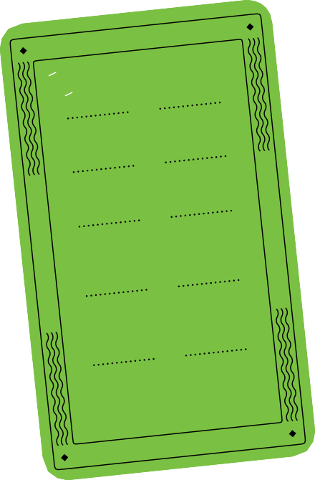Being as prepared as possible will help to minimise feelings of stress. This includes:
  - having your clothes ready
  - bit of knowledge about the business/organisation
  - journey planned
  - thought about some responses to common interview questions
Arriving ten minutes early not only shows that you’re organised; it also helps relieve your own stress avoiding a last minute rush to get there.
Visualisation is a relaxation technique in which you imagine yourself succeeding in the situation. By doing so, you’re mentally preparing to handle the event in real life.
You can practise visualisation in the days, hours or even minutes before an interview. Simply close your eyes and breathe deeply. Picture yourself greeting the interviewer confidently and answering tough questions with ease.

During the interview
- Breathing deeply and slowly (and quietly, of course)
- Sit up straight and don’t cross your legs or arms
- Keep your hands and jaw relaxed, not clenched
- Smile
- Speak slowly and pause for breath often. If you reach a question that you can’t think of a response straight away, take a moment to think and maybe even paraphrase the question out loud. Don’t panic, take your time to breathe and regain your focus.
- It’s okay to admit that you’re nervous. Interviewers don’t see this as a weakness.

Who you can talk to if you’re experiencing high level stress or anxiety:
If the feelings of stress begin to affect your mental and/or physical health, you may need to seek support.
- School staff (welfare staff, school nurse, teachers)
- An adult you trust
- Your GP (doctor)
- Local service (headspace, youth services etc.)
- www.eheadspace.org.au or 1800 650 890
- Lifeline (24hr): 13 11 14 – crisis support, free from mobiles
- Kids Helpline: 1800 55 1800 & Web – free/ confidential
- headspace.org.au
- Emergency: 000

Use an
Anti-Anxiety Card to tackle interview stress

LESSON 6:
PREPARING FOR AN
INTERVIEW (SESSION 2)

INTERVIEW QUESTIONS
Below are the set questions that the interviewer will be using during the mock interview event.
Practising answers for these questions will help you once you get into the interview situation.
  - Icebreaker question:
The interviewer will take a quick look at the candidates resume to see if there are any questions they could ask which are relevant to the job or things which are interesting
e.g. special awards, general interests, hobbies etc.

USING S.A.O RESPONSES
When answering interview questions, it is recommended that you use the SAO approach.
It’s also a good idea to use this approach when responding to Key Selection Criteria.
S A O

SITUATION ACTION OUTCOME

General question: Tell us a little about yourself?
  - Why would you like to do this job or work for this company?
  - Have you ever been involved in any work experience /
Where and when you did something

Example
What you did and how you did it
What the result of your actions were

volunteering / paid employment before?
  - If student answered yes: Can you tell me a little about what you did, where it was and how you went?
  - If student answered no: Can you tell me about any subjects, training or activities you have been involved in at school or in your community that might assist you in this job?
  - What qualities or skills do you think you can offer for this job?
  - Can you give me an example from school or work where you have worked in a team to complete some task?
  - Can you think of a time when you have had to solve a problem at school/at work/at home/ somewhere else,
describe how you went about it and what the outcome was?
  - Would you like to ask me any questions?
Interview Question - What are your time management/ organisational skills like?
SITUATION I am currently undertaking a VET subject in fashion design, as well as my other normal Year 10 subjects. This requires that I travel to do VET at my local TAFE every Wednesday afternoon and miss two periods of other subjects.
ACTION I have to find time to speak to 2 of my class teachers in the subjects that I have missed for the week, to review the work and homework assigned.
OUTCOME As a result of this action I am progressing well in all my subjects

INTERVIEW EVALUATION FORM
- PG 1
Disclaimer: All evaluations are conducted to assist students in obtaining practical interview skills for future opportunities

INTERVIEWER NAME STUDENT NAME SCHOOL NAME

QUESTION RESPONSE/ PERFORMANCE | RATING  SCALE 1 - 5  1- NEEDS IMPROVEMENT  5- VERY COMPETENT | COMMENTS
Resume standard
Handshake
Professional Appearance
Self Confidence, comfort level
Consider the following elements:
- Voice Tone, Volume
- Posture, Body position
- Eye Contact
Use of selling points

INTERVIEW EVALUATION FORM
- P2
QUESTION RESPONSE/ PERFORMANCE | RATING  SCALE 1 - 5  1- NEEDS IMPROVEMENT  5- VERY COMPETENT | COMMENTS
Question responses:
Provide either an overall evaluation comment about all of the answers provided or you can comment on individual question responses below.
Response to Qn 1:
Icebreaker question
Response to Qn 2:
Why would you like to do this job or work for this company?
Response to Qn 3:
Have you been involved in any work experience/volunteering/paid employment before?
If Yes, can you tell me a little about what you did?
If No, can you tell me about any subjects, training or activities you have been involved in at school or in your community that might assist you in this job?
Response to Qn 4:
What qualities or skills do you think you can offer for this job?
Response to Qn 5:
Can you give me an example from school or work where you have worked in a team to complete some task?
Response to Qn 6:
Can you think of a time when you have had to solve a problem at school/at work/at home/somewhere else?
Describe how you went about it and what the outcome was.
Response to Qn 7:
Would you like to ask me any questions?

