APPLYING FOR A JOB (SESSION 1)

TOPICS
Power words and statements Resume Builder (part 3) Resume writing

LEARNING INTENTION
The learner has an understanding of how to write an accurately formatted and comprehensive resume,
communicating best aspects of themselves to the employer.

FOCUS
How to use power words and statements, and creating a first draft resume.

STUDENT OUTCOMES
- Understanding of power words and statements, and how they can be tailored towards an application
- Understanding of what a quality resume should feature, and ability to present their skills and experiences in a resume format
- Ability to personalise a resume in response to the job requirements

OUTLINE

Power words and statements
Open a discussion about what power words and statements are and how they can boost a resume. Brainstorm power words for the three industries listed. Supported by page 29 hand out.

Resume Builder part 3
Complete part 3 of the Resume Builder handout ‘power words and statements’. This handout can be found on page 17.

Resume writing
Hold a discussion about why a resume is important. Review the ‘ingredients for a great resume’ on page 30, and the sample resume template 31-32.
Using the information already filled in by students on the ‘Resume Builder’ handout (pages 15-17), start on the first draft of a resume.

Once students have a draft of their resume, they can upload the file to jobsforyouth.com.au to create an Air CV (a visual snapshot version of the resume). This process pulls out the keywords used on the resume, so it’s a good way
to review if the ones used are effective. It will also suggest additional keywords based on what has been included, so this might help with adding value.

OUTPUTS
- Resume Builder part 3 completed
- First draft of resume, written to target students selected job ad.

POWER WORDS AND STATEMENTS
Power words and statements describe you, your values, your attitude and approach to employment.
These words can be used on a resume to describe personal attributes.
Power words can be targeted to reflect the industry you are applying for.

Examples:
- Customer Service position – friendly and engaging phone manner, good people skills, interested in helping people

Carpentry apprenticeship – ability to measure accurately, hard working and enthusiastic about the building industry, willing to learn new skills

Brainstorm Power words for the following industries
Fashion Retail
Apprentice Horticulture
Administration Assistant

POWER WORDS AND STATEMENTS
– CONTINUED
Create a list of power words and statements
In response to your chosen job ad, create a list of power words and statements in your Resume Builder – part 3. These words will be used in your resume and cover letter.

Sample power words /statements
active | adaptable | ambitious | assured | attention to detail | calm
caring | cheerful | considerate | conscientious | hard working | consistent
creative | credible | dependable | determined | diligent | diplomatic
discreet | dynamic | eager | efficient | energetic | enterprising

enthusiastic excellent flexible focused generous happy honest independent industrious knowledgeable level-headed loyal mature methodical motivated open passionate persistent practical productive professional punctual quick-learner realistic receptive respected resolute responsible self-starter sincere steadfast studious tactful team player thoughtful tough trustworthy unbiased vigorous warm welcoming willing

RESUME WRITING

Why is a resume needed?
  - Resumes are expected for almost all types of jobs from Clerk to Chief Executive Officer
  - Resumes allow you to have all the facts in the one place
  - A strong resume can make you appear more professional than another candidate

Ingredients for a great resume
The job market is competitive; sometimes one job can have a huge number of applicants. In these situations, an
employer/ recruiter only spends an average of 6 seconds per resume!
This means, you need your top selling points and why you’re best suited to the job, front and centre.
Make your writing clear and to the point, in a 1-2 page resume.
  - Sell yourself! In many job application processes, a strong resume is your ticket to an interview
  - Effective keywords/ power words and statements in response to the job ad you’re applying for. Your resume should be customised for each individual job you apply for
  - Computer generated with simple formatting, font size 11 or 12 point in black or grey, printed on clean white paper
  - 1–2 pages in length
  - Include accomplishments, awards and achievements
  - Focus on your strengths, but never exaggerate the truth
  - Include all current contact details for yourself and referees
  - Explain gaps in employment history (travelling, parenting, studying etc.)
  - Leave out: date of birth, place of birth or marital status. These items do NOT need to be included
  - Have someone proofread your resume for mistakes or

information that may have been overlooked

What to write if you havent had a job yet
Even though you may not have had work experience, you can still highlight the skills, abilities and experience you’ve gained through school, training, voluntary positions or community group involvement. Examples:
- When including relevant experience specific to the job – “I have two years’ experience with all aspects of customer service and retail sales gained as a part-time volunteer with the Salvation Army’s Savers program”
- Key skills, qualities and abilities specific to the job – “I have hands-on experience with a range of computer applications. I work well with others in stressful situations.”
- Relevant qualifications or training/academic track record specific to the job – “My studies have focused on mathematics and science, and I took additional applied maths and chemistry electives in Year 11.”

LESSON 3:
APPLYING FOR A
OBJECTIVE
JOB (SESSION 1) 2

SAMPLE RESUME 3

Contact details
Provide your full name (or preferred name.
Include your postal address, phone number and email address.
Make sure your phone has a clear voicemail message or that there is someone available to 4
EDUCATION
2019
take a message for you.
Be sure to include an email address that looks professional (i.e. nothing like
sugar_coated@hotmail.com). If you don’t 5
have a suitable email, now is the time to
create a new account!

Objective
A career objective explains what you’re looking for and what you can offer. It shows that you’ve thought about what kind of work you want to do.
Keep it brief (one or two sentences). It can be written to suit each job you apply for or it can be more general to suit your overall career or job goals.

Achievements & abilities
Include any formal achievements e.g. awards or certificates such as First Aid, a music or sport qualification.
Now think about more informal 6
achievements (things you’re proud of ) based on your activities, hobbies and interests both in school and out of school e.g. clubs you belong to, tasks you help out with at home or
in the community. 7
REFEREES
Anna Bell
After School Care Manager Highfield Primary School 0400 111 222
Written reference enclosed
Abilities refer to the skills you have listed in your Resume Builder document.

8
1
Mary Richards 12 Orchard Grove, Highfield, 3023
0412 566 310
mary.richards@gmail.com

Cameron Davies
I am seeking the opportunity to expand my skills, knowledge and
experience in a junior role. I am eager to learn and open to tackling a
range of tasks.
ACHIEVEMENTS & ABILITIES
•
•
•
•
A team player and strong communicator Organised and great attention to detail
Takes pride in work and always achieves tasks to high quality
Computer skills: including word-processing, spreadsheets, research
and social media
Working with Children Check – volunteer Certificate – Introduction to First Aid
•
•
PROFESSIONAL EXPERIENCE
March 2017 to Present
Highfield Primary School
After School Care Assistant – Voluntary
The Highfield Primary School after school care provides a safe and nurturing environment for up to 30 students.
Responsibilities: As after school assistant I support the Coordinator to organise recreational activities
and healthy snacks for the students. I have become
efficient at preparing and packing up activities and completing general administration in short time frames.
Practical Shoes
Reception and Administration – School work experience Practical shoes are a local shoe manufacturer that produces shoes and boots for work wear.
Responsibilities and achievements: During my two week work experience I completed a range of duties including answering phone enquiries, uploading content to the online store (Shopify platform), filing and general office duties.
June 2019
(2 weeks)
INTERESTS
•
School basketball team member - premiership team in 2018
•
•
YMCA Computer Clubhouse member
Australian Youth Climate Coalition member
Year 10, Highfield Secondary College
Current student
Subjects include English, Social Science, Mathematics, Biology, Geography
Teacher
Highfield Secondary School 03 9300 1111

LESSON 3:
APPLYING FOR A JOB (SESSION 1)

SAMPLE RESUME CONTINUED

Education
You can list your subjects and results or just name the last year of school you completed (where and when) – it’s up to you.

Professional experience
Include any relevant work experience (position, name of employer and length of employment). Start with the most recent and work backwards.
Include a sentence about the employer. This shows you had an understanding of their core business/mission.
Aim to include some of the responsibilities you had in this job, and also any achievements you had, whether it was an achievement for the organisation or yourself.

Interests
Writing a bit about what you do in your spare time helps an employer get to know you. It’s another chance to draw attention to your abilities and achievements.
Include things like team memberships, long-term interests and any informal training you’ve done through a social club or community group.

Referees

Who can be a referee?
Someone who knows you well, like a colleague, team- mate, coach, mentor, teacher or another member of the community you’ve worked with or helped out. Avoid using family or close friends as referees unless there are no alternatives.
Make sure you provide up-to-date contact details of your referees and always make sure you have permission before including them in a resume.
Always let your referees know if you’re going for an interview. This means they will be prepared and expecting a call from the employer. It also helps to tell referees about the job you’re applying for so they can think about how your skills and abilities will be relevant.

Written References
Written references are very useful to add to your resume to highlight your skills. You can ask referees to write you a reference that describes your best skills and qualities.

APPLYING FOR A JOB (SESSION 1)

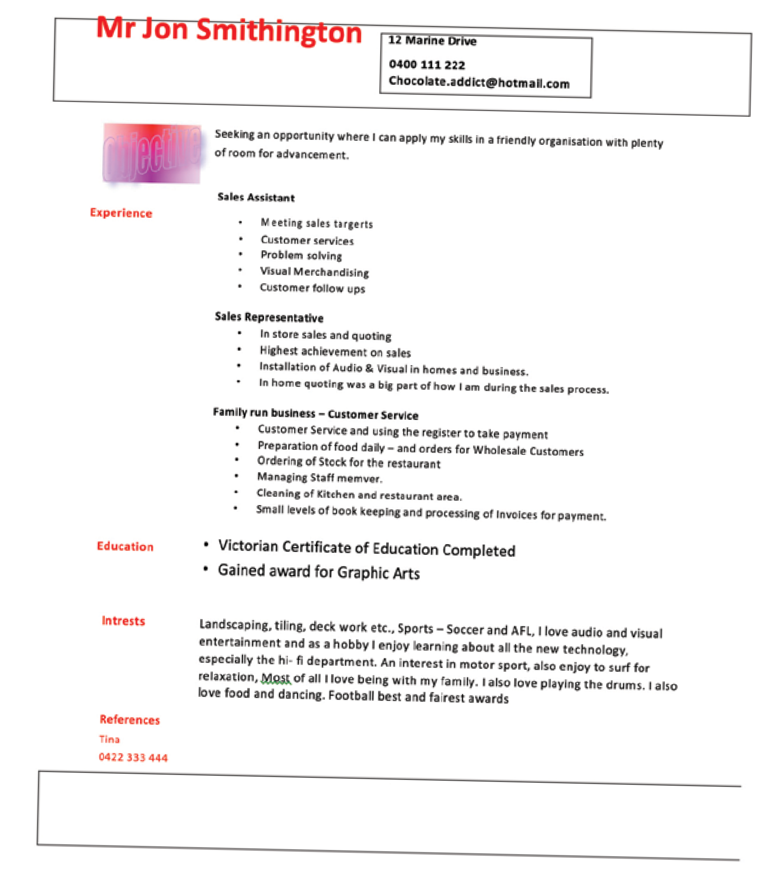RESUMES, WHAT NOT TO DO

APPLYING FOR A JOB (SESSION 1)
WRITING YOUR RESUME DRAFT

Get started on your resume
Using the information you have filled out on the Resume Builder handout (page 15-17), start the first draft of your resume. Remember, it should be tailored to respond to the job ad you have chosen.
If you already have a resume, edit it so that it responds to your chosen job ad.
You can download a copy of the RIJI resume template at jobsforyouth.com.au in the Real Industry Job Interviews section.
More resume samples can be found here:
  - www.youthcentral.vic.gov.au/jobs-careers/applying- for-jobs/resume-template-vce-no-paid-work- experience
  - myfuture.edu.au/career-insight/how-to-write-an- effective-entry-level-resume
Make sure your resume uses correct spelling and grammar, clear formatting, and profiles your skills and commitment to your targeted job.

Social Media check
It’s not uncommon for employers to screen candidates by checking social media profiles. Go through all of the digital accounts you have created and make sure your photos and information have adequate privacy settings, and are not embarrassing towards your professional persona in your job search!

Create an Air CV
Login to jobsforyouth.com.au to create your AirCV. An AirCV is a visual snapshot of your resume that can be uploaded and used to apply quickly for exclusive jobs on Jobs for Youth. The AirCV aims to capture your skills and experience in a visual timeline. With your AirCV on
jobsforyouth, you can choose to make it open for employers and recruiters to find it when they search for candidates.

To create an AirCV, navigate to the top black bar and click on ‘AirCV’. Fill the fields public username, long story short (sell yourself! e.g. “Enthusiastic, willing to learn, interested in sales”).
There are then two options:
- Fill out each field career overview, skills and capabilities, experience, and education.
- Or you can upload your resume file. After you have uploaded the file, click ‘edit resume’ to customise the dates, skills and text.

Note the key words it pulls out
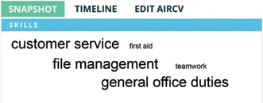

Some larger employers use software to scan resumes for keywords and shortlist them before they’re even read by a person! Air CV also suggests additional keywords based on what you have entered.

