SELF ASSESSMENT

TOPICS
Student RIJI Program Survey
Identifying strengths and skills – Online Activity Exploring careers
Identifying strengths and skills – Matching skills to careers Career aspirations
Resume Builder (part 1)

LEARNING INTENTION
The learner has identified the broad range of skills which they can bring to a job.

LESSON 1:
SELF ASSESSMENT

FOCUS
In this introductory session students explore career aspirations, and identify skills that they can bring to a job.

STUDENT OUTCOMES
- Understand the value of working
- Insight to the broad number of careers connected to learning areas of interest
- Identify job related skills- and those they recognise as relevant to themselves
- Identify personal career goals.

OUTLINE

Student RIJI Program Survey
As part of our commitment to ensuring the RIJI Program continues to improve, and to measure students’ progress, we require students to complete a pre and post program survey.
Please have your students complete the student RIJI survey prior to and after completing the RIJI Program. The aim is for students to assess their skills and knowledge related to interview preparation.

Identifying strengths and skills – Online Activity
In this online activity, students undertake the myfuture interests and skills quizzes to help identify their top strengths and skills.

Exploring careers
In this online activity, access the myfuture website to explore careers sorted by learning area. Identify the breadth of careers associated with a single learning area, and note the pathways required to obtain these careers.

Identifying strengths and skills- Matching skills to careers
An activity to consider the skills required for specific careers.

Career aspirations
Open a discussion about the value of working and students’ short and long term job and career aspirations.

Resume Builder (part 1)
Students complete part one of the Resume Building handout, ‘Summary of your top skills’ and ‘Objective’ on page 14. Students will add to this document throughout the first three lessons of the program. The final document will help to shape students resume, cover letter, interview answers and will help to build a greater understanding of the type of job they wish to target.

OUTPUTS
- Resume Builder (part 1) completed.

STUDENT RIJI PROGRAM SURVEY
- Print the following page and have students complete the survey at the beginning of the program.
Take the document back and file it.
- Closer to the interview event in Term 3, a Surveymonkey link for the final data collection will be provided to teachers. Distribute this link to every participating student to access the survey.
- As soon as possible after the event, have the students access the Surveymonkey link and enter their answers collected on the document in step 1, and enter their new responses for the post-program perspective. The post- program survey will also include additional questions for students to help improve the program.
Please note that the Surveymonkey link can only be accessed once per person, so it isn’t possible for students to save their survey entry mid way and reload the survey.
- You may wish to allocate time in class to get the survey responses entered into Surveymonkey soon after the event. This will help us to quickly provide the report back to all participating schools.

LESSON 1:
SELF ASSESSMENT

STUDENT RIJI PROGRAM SURVEY

Student Name: School: Year Level:
Subject Area:
The RIJI Program is designed to help you build your job- seeking and application skills.
Please self score yourself on the following statements below by honestly rating your current skills and knowledge before starting the program.
You will be asked to self score yourself again after completing the RIJI program.

Please indicate how much you agree or disagree with the statements below. 0 = strongly disagree, 5 = strongly agree.

BEFORE PROGRAM |  | AFTER PROGRAM
I understand what employers look for in employees. | 0 1 2 3 4 5 | 0 1 2 3 4 5
I understand my career options and what I would like to do in the future. | 0 1 2 3 4 5 | 0 1 2 3 4 5
I know how to look for jobs. | 0 1 2 3 4 5 | 0 1 2 3 4 5
I know how to write a good cover letter. | 0 1 2 3 4 5 | 0 1 2 3 4 5
I know how to write a good resume. | 0 1 2 3 4 5 | 0 1 2 3 4 5
I know how to prepare for a job interview. | 0 1 2 3 4 5 | 0 1 2 3 4 5
I am confident I can do well in a job interview. | 0 1 2 3 4 5 | 0 1 2 3 4 5
I know how to communicate well in an interview. | 0 1 2 3 4 5 | 0 1 2 3 4 5
Teachers: Please collect the students’ self score sheets after rating their current skills and knowledge before starting the program. Please return to students and ask to then rate skills and knowledge after completing the program using the Surveymonkey link provided.

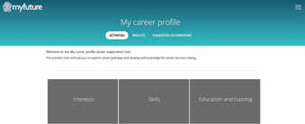LESSON 1:
4
1
SELF ASSESSMENT

IDENTIFYING STRENGTHS AND SKILLS
Understanding your strengths and skills is an important factor in your job searching process. This knowledge can:
- Help you pick jobs suited to you
- Be included on your resume and cover letter
- Help you to answer questions about yourself in a job interview
Help you realise that you have skills and attributes relating to a number of career options that you had previously not considered. Most skills are suited to a range of different career options.

ONLINE ACTIVITY

Take the myfuture interests and skills quizzes

- Navigate to myfuture.edu.au
- Create an account
- On the menu (right hand side), click on ‘my career profile’
- Complete the two quizzes under ‘interests’ and ‘skills’.
The quizzes include multiple choice questions and take approximately 5 minutes each
- 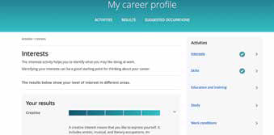A results summary is generated that identifies a dominant skill area under the categories ideas, people, things, and data.
5

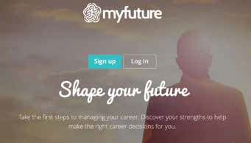myfuture.edu.au
2

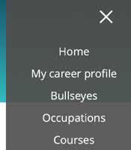
3

LESSON 1:
SELF ASSESSMENT
EXPLORING CAREERS
There are so many different types of jobs out there, even jobs that haven’t been invented yet!
It can be difficult to imagine what jobs you might have in the future. In fact, many people end up in a career they never imagined when they first set out.
A good place to start thinking about your future jobs and careers is by thinking about your passions, and things that you’re naturally good at.
Follow the instructions below to view the Careers Bullseyes, and start by choosing a learning area that you enjoy.

ONLINE ACTIVITY

Explore Career Bullseyes

- Navigate to myfuture.edu.au
- On the menu (right hand side), click on ‘Bullseyes’
- 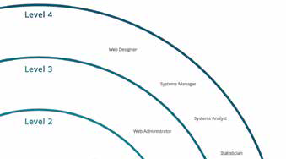Explore career pathways by clicking on a learning area you enjoy
4
- The bullseye is separated into four levels: from school graduate or Cert I and II, to higher education. Inside each level are some job examples. Click on a job to see an overview of what that occupation does.
- In the top menu, click on ‘pathways’ to see some examples of the types of pathways that can lead to this job.

myfuture.edu.au
2

3

1

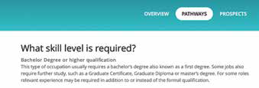
5

LESSON 1:
SELF ASSESSMENT
IDENTIFYING STRENGTHS AND SKILLS – MATCHING SKILLS TO CAREERS
This activity encourages students to consider the skills required for specific careers. This activity aims to help students realise that they have skills that relate to more than one career path.

Make up career cards
Write a variety of careers/ jobs on each card. Some ideas have been provided in the list below. Scatter the cards on a table so that the students can walk around the table to look at and select various career options.

Identify 5 skills
Ask students to write down 5 things that they recognise themselves to be good at.

Matching skills to careers
Ask the students to look at the careers cards on the table and try to match the 5 identified skills with 5 careers.

Brainstorming further careers and jobs
Ask the students to make a list of further careers or jobs that relate to their five identified skills.

DISCUSSION

Discuss the results, with students giving examples of their findings.

SKILLS
Skill examples to get you started:
- communication
- creative thinking
- innovation
- technology literacy
- team player
- organised
- time management skills
- works well under pressure
- problem solving
- take initiative
- multi tasking
- researching

CAREERS/JOBS LIST
Accounting Advertising Aged Care
Asset Maintenance Baker
Banking
Barista (Coffee Art) Beauty Therapy & Makeup
Boiler Making, Fitting & Welding Butcher
Chef Child Care
Customer Service Defence Services Design
Drafting Electrician Florist
Food Preparation Government Services Health Worker Horticulture
HR or Recruitment Info tech
Legal
Logistics, Supply & Transport Landscaping
Machining Marketing Mechanic Medicine Multi Media Panel beating Real Estate Receptionist Sales
Teaching / Training Travel & Tourism Waiter Warehousing Youth Work

LESSON 1:
SELF ASSESSMENT

CAREER ASPIRATIONS
Students consider personal job and career aspirations, both short term and long term.

Open a discussion about the benefits of working and job aspirations.

DISCUSSION POINTS

How working can benefit you
- Getting a job can set you on a career path that not only builds skills, but builds confidence and self esteem
- Financial independence will give you more freedom and choices in your life
- The whole cycle of working and participating in the wider community will enhance your life and make it more satisfying and rewarding for you
- Valuable skills can be developed, so that you can progress along your career path to achieve higher and better paid positions.

Job and career aspirations
Do students have any short term/ long term ideas in mind for jobs and careers?
What skills are they currently developing in a job, or sports groups, community involvement or school and VET subjects?

RESUME BUILDER – PART 1
Complete part 1 of the Resume Building handout ‘Summary of your skills and ‘Objective’ setting a SMART goal. This handout can be found on page 15. (part 2 and 3 will be used in the lessons that follow).

RESUME BUILDER
– PART 1

Name:

Date:

MY TARGET POSITION
Summary of your top skills/strengths: your top 4 to 6 selling points for the target position

Objective: Set a SMART goal to do with a job/career goal, it can be a short or long term goal A SMART goal is Specific
Measurable Attainable Relevant Time Bound

SPECIFIC | MEASURABLE | ATTAINABLE | RELEVANT | TIME BOUND
What is your goal? Include details (who, what, when, where, how) | How will you know when you have achieved the goal? | Is the goal achievable? | Why is this goal important to you at this point in your life? | How long will your goal take to achieve?

RESUME BUILDER
– PART 2

EMPLOYER’S REQUIREMENTS

From the job ad you have chosen, what are the employer’s top 3 needs and how you meet them?

Employer’s need #1:
Your examples that you meet this need:

Employer’s need #2:
Your examples that you meet this need:

Employer’s need #3:
Your examples that you meet this need:

EXPERIENCE

What experience have you had that proves your ability to do the job? Start with your most recent experience first. Experiences can be from jobs, at school, organisations or volunteering.

TITLE EXPERIENCE DATES

RESUME BUILDER
– PART 3
EDUCATION
List any relevant education and training.

QUALIFICATIONS OBTAINED INSTITUTION DATES

POWER WORDS AND STATEMENTS
In response to your chosen job ad, create a list of power words and statements:

