STUDENT RIJI PROGRAM SURVEY

Student Name: School: Year Level:
Subject Area:
The RIJI Program is designed to help you build your job- seeking and application skills.
Please self score yourself on the following statements below by honestly rating your current skills and knowledge before starting the program.
You will be asked to self score yourself again after completing the RIJI program.

Please indicate how much you agree or disagree with the statements below. 0 = strongly disagree, 5 = strongly agree.

BEFORE PROGRAM |  | AFTER PROGRAM
I understand what employers look for in employees. | 0 1 2 3 4 5 | 0 1 2 3 4 5
I understand my career options and what I would like to do in the future. | 0 1 2 3 4 5 | 0 1 2 3 4 5
I know how to look for jobs. | 0 1 2 3 4 5 | 0 1 2 3 4 5
I know how to write a good cover letter. | 0 1 2 3 4 5 | 0 1 2 3 4 5
I know how to write a good resume. | 0 1 2 3 4 5 | 0 1 2 3 4 5
I know how to prepare for a job interview. | 0 1 2 3 4 5 | 0 1 2 3 4 5
I am confident I can do well in a job interview. | 0 1 2 3 4 5 | 0 1 2 3 4 5
I know how to communicate well in an interview. | 0 1 2 3 4 5 | 0 1 2 3 4 5
Teachers: Please collect the students’ self score sheets after rating their current skills and knowledge before starting the program. Please return to students and ask to then rate skills and knowledge after completing the program using the Surveymonkey link provided.

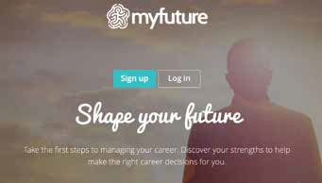IDENTIFYING STRENGTHS AND SKILLS
2
Understanding your strengths and skills is an important factor in your job searching process. This knowledge can:
- Help you pick jobs suited to you
- Be included on your resume and cover letter
- Help you to answer questions about yourself in a job interview
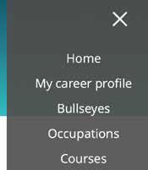Help you realise that you have skills and attributes relating to a number of career options that you had previously not considered. Most skills are suited to a range of different career options.
3

ONLINE ACTIVITY

Take the myfuture interests and skills quizzes

- Navigate to myfuture.edu.au
- 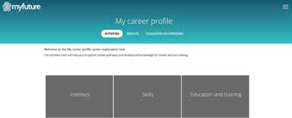Create an account
4
- On the menu (right hand side), click on ‘my career profile’
- Complete the two quizzes under ‘interests’ and ‘skills’.
The quizzes include multiple choice questions and take approximately 5 minutes each
- 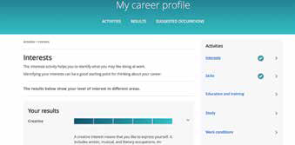A results summary is generated that identifies a dominant skill area under the categories ideas, people, things, and data.
5

LESSON 1:
SELF ASSESSMENT

EXPLORING CAREERS
There are so many different types of jobs out there, even jobs that haven’t been invented yet!
It can be difficult to imagine what jobs you might have in the future. In fact, many people end up in a career they never imagined when they first set out.
A good place to start thinking about your future jobs and careers is by thinking about your passions, and things that you’re naturally good at.
Follow the instructions below to view the Careers Bullseyes, and start by choosing a learning area that you enjoy.

ONLINE ACTIVITY

Explore Career Bullseyes

- Navigate to myfuture.edu.au
- On the menu (right hand side), click on ‘Bullseyes’
- 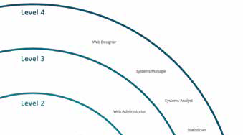Explore career pathways by clicking on a learning area you enjoy
4
- The bullseye is separated into four levels: from school graduate or Cert I and II, to higher education. Inside each level are some job examples. Click on a job to see an overview of what that occupation does.
- In the top menu, click on ‘pathways’ to see some examples of the types of pathways that can lead to this job.

myfuture.edu.au
2

3

1

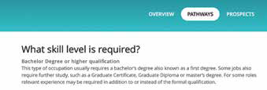
5

