session Date
Transition Review Process
session TWO: The GRID

STRENGTHENING THE FOUR PHASES AND FIVE AREAS
OF ACTION IN TRANSITION

Primary & Secondary School Resource
Updated July 2019

The INLLEN acknowledges the support of the Victorian Government.

School Name
STEP THREE / SESSION TWO: THE GRID

Session Two will involve work around the Four Phases and Five Areas of Action in Transition.
This includes:
- Familiarising participants with the definition of the Four Phases and Five Areas of Action in Transition
- Identifying all of the School’s current transition related activities
- Mapping the School’s current transition related activities against the Four Phases/Five Areas of Action in Transition Grid
- Identifying strengths and opportunities within the School’s current Grid
- Identifying gaps within the School’s current Grid
- Presenting examples of possible activities that fit within The Grid
- Exploring and adding in activities that should be in the School’s revised Grid (keeping in mind priority items identified through the Audit)
The Four Phases and Five Areas of Action in Transition were identified through the Joining the Dots research as a useful framework for classifying and discussing transition processes and good practice. Citing extensive research undertaken in the U.K., this framework has been referenced and adapted by the N.S.W. Department of Education and Training (2007). This has now been further updated to reflect the five key dimensions of the Joining the Dots Transition Model (2018). Research shows that effective transition practice should include all Four Phases and Five Areas of Action in Transition.
Within this framework, schools are able to chart their transition related activities on The Grid, and get a visual representation of their current transition practice/program. This provides schools with an opportunity to realise strengths, opportunities and areas for improvement for revised transition and engagement practice.
Please note that although The Grid focuses on transition between Years 4-9, it can easily be adapted for use by a primary or secondary setting to map whole school intra-transition.

Resources required
- Facilitator (external or school staff member)
- Session Two Workbook: Strengthening the Four Phases and Five Areas of Action in Transition
- Laptop and Scribe

THE FOUR PHASES OF TRANSITION
- Preparation (approx. Year 4- Year 6, Semester 1)
This Phase includes activities designed to introduce and prepare primary school students and families for their choice of, and transition to, secondary school.

- Transfer (approx. Year 6, Semester 2)
This Phase refers to the period of time when feeder and destination school staff are facilitating the transfer and placement of each student into their new school. Students are feeling increasingly anxious about transition, particularly those more vulnerable.

- Induction (Year 7, Semester 1)
This Phase begins upon entry into secondary school. Activities are intended to orientate students to the expectations and operation of the school, as well as provide support for learning and social and personal aspects of transition.

- Consolidation (Year 7, Semester 2 – Year 9)
As transition activities tend to merge into the secondary school’s wellbeing and support programs, this Phase recognises the need to provide students with the means to manage their own learning and focus on their engagement beyond Year 7.
THE FIVE AREAS OF ACTION IN TRANSITION
The five areas of action reflect the five key dimensions of the JTD Transition Model.
- Organisation and Resourcing
This Area covers how organisations involved in transition need to have comprehensive and well communicated transition programs, supported by appropriate structures, processes and resources.

- Sharing Knowledge and Practice
This Area includes primary and secondary schools working collaboratively and cooperatively to improve the transition experience of students and their families.

- Family and Community Engagement
This Area focuses on student learning that is supported by families and the broader community working in partnership with the School. Support includes capability building activities for school staff, families and agency workers to better support student engagement in learning.

- Student Engagement
This Area enables students to fully participate in their education. They should feel a sense of belonging and connectedness to school, be intrinsically motivated and self regulating, are well organised and socially competent. Included within this are the three types of engagement – behavioural, emotional and cognitive.

- Student Voice
Within this Area students’ are enabled and encouraged to contribute to decision making about transition and collectively influencing transition outcomes by putting forward their ideas, views and concerns, and developing resources.

For examples of appropriate strategies/actions within each Area, please refer to the Joining The Dots Transition Model that follows The Grid.
GROUP ACTIVITY: Completing The Grid
Depending on your school, and the number of participants involved in Session Two, inputting your school’s current transition related activities in The Grid can be completed in a number of different ways including:
- All participants are to work through the activity together and contribute to all Phases and Areas of Action at the same time,
- Participants to work in pairs/small groups to work through the whole Grid before sharing with the rest of the group, or
- Participants to work in pairs/small groups to complete a particular Phase or Area of Action on their own before sharing with the rest of the group.

Suggested steps when completing The Grid:
- Make a list of your school’s current ‘transition’ related activities on page 5 (if you don’t have it recorded elsewhere). Consider all activities in place for transitioning students and families (in class, incursions and excursions) as well as those more targeted activities for vulnerable cohorts.

- Consider if and where each activity fits on The Grid and add it to the template.
Please note the following when populating The Grid:

- Primary setting – please focus on the first three phases of transition as opportunities for Consolidation largely focus on evaluation feedback from secondary staff, students and families, as well as continued Cluster/Network meetings.

- Multiple Areas/Phases - an activity may potentially fit in more than one cell so where applicable, please extrapolate these across Areas/Phases, adding a little detail about timing and target cohort in each phase.

- Part-way Transition – please ensure that you include processes/programs for students who arrive and/or leave part-way through a year level, remembering that they may also come from or go to a different sector (Catholic/Government/Independent, primary/secondary). These students are generally more vulnerable than their peers who benefit from orientation programs at the start of the year/end of the year prior to transition. Extra supports should be put in place to support/follow-up these students and their families.

- Students vulnerable to disengagement - Vulnerable students are not just those at the ‘pointy end’ who require large amounts of support - academic and/or wellbeing. Often there is a larger group of students who are flying just below the radar, just doing enough to get by but falling short of reaching their full potential. There are a range of factors that may contribute to a student’s disengagement from their learning. These include:
- Family and community factors such as poverty, parental unemployment and/or low educational attainment, homelessness, transience or living in out-of-home care, Aboriginal or Torres Strait Islander status, refugee background, family breakdown/relationship issues and domestic violence.
- Personal factors such as physical or mental health issues, disability, behavioural issues, offending behaviour and/or contact with police or justice system, substance misuse or dependency, pregnancy or parenting, caring responsibilities, and learning difficulties.
- School-related factors such as negative relationships with teachers or peers, unsupportive school culture, limited subject options and lack of student participation in decision making.

Young people may often experience multiple risk factors, which may be interdependent. For example, family breakdown may be a factor in substance misuse, which may itself contribute to other problems such as offending behaviour.

The impact of risk factors on engagement, health and wellbeing will vary between individuals. It depends on their levels of resilience and protective factors such as support from a trusted adult.

Source: Victorian Department of Education and Training

- Organisation & Resourcing - This Area should include the School’s organisational structure, processes and resourcing that enables and sustains good transition practice. e.g. Transition Coordinator PD and time fraction; Transition Working Group & meetings; Transition Policy; documented & communicated practice; staff professional learning and knowledge sharing; commitment to a whole school approach; processes for collecting, collating and analysing student data; evaluation.

- Sharing Knowledge & Practice – This area is solely for interactions between settings e.g. Transition Cluster meetings, student transition information form, student transition information meetings with Transition Coordinator/teacher(s)/wellbeing in other setting, learning tours of other settings by teachers to understand curriculum and teaching and learning practice.

- Student Engagement - When completing this Area, please ensure that you consider all three elements of student engagement – Behavioural, Emotional and Cognitive. All three work in unison and definitions follow for each:

  - Behavioural - refers to active participation or involvement with the classroom or schooling environment, and can be reflected in attendance or concentration in the classroom.
  - Emotional - involves the affective response to other students, teachers, or whole school community and is characterised by feelings of school belonging and/or familiarity with teachers.
  - Cognitive - refers to beliefs about the importance of school and commitment and critical thought with the processes of enquiry, for example, learning for meaning by asking questions.

- Complete the Discussion Questions that follow The Grid

- Update The Grid with any new activities identified in the Discussion

1. LIST ALL OF YOUR SCHOOL’S CURRENT TRANSITION RELATED ACTIVITIES BELOW, INCLUDING ACTIVITIES TARGETING SPECIFIC/VULNERABLE COHORTS

e.g. Year 7 Orientation Day, student visits to primary/secondary school, teacher professional learning, sharing student information between settings, working in partnership with local community agencies to build capability, transition program evaluation surveys and consultations, transition cluster meetings, transition working group meetings, monitoring attendance and punctuality data, creating student stories/videos about transition, buddy system, managing anxiety sessions/mental health awareness, getting organised/study skill sessions for students …

 | ACTIVITY NAME & BRIEF DESCRIPTION | YEAR LEVEL(S) | ALL STUDENTS / TARGETED COHORT
1
2
3
4
5
6
7
8
9
10
11
12
13
14
15
16
17
18
19
20
21
22
23
24
25
26
27
28
29
30

2. THE GRID TEMPLATE – POPULATE WITH CURRENT TRANSITION ACTIVITIES
4 PHASES  5 AREAS | PREPARATION  Year 4 – Year 6 Sem.1  Includes activities designed to introduce and prepare primary school students and families for their choice of, and transition to, secondary school. | TRANSFER  Year 6 Semester 2 approx.  Refers to the period of time when feeder and destination school staff are facilitating the transfer and placement of each student into their new school. Students are feeling increasingly anxious, especially those more vulnerable. | INDUCTION  Year 7 Semester 1 approx.  Begins upon entry into secondary school. Activities are intended to orientate students to the expectations and operation of the school, as well as provide support for learning and social and personal aspects of transition. | CONSOLIDATION  Year 7 Sem. 2 – Year 9  As transition tends to merge into the wellbeing and support programs, this Phase recognises the need to provide students with the means to manage their own learning and focus on their engagement beyond Year 7.
ORGANISATION AND RESOURCING  Organisations involved in transition having comprehensive, embedded and well communicated transition practice, supported by appropriate structures, processes & resources. | Organisational Structure
 | Processes & Resourcing
SHARING KNOWLEDGE AND PRACTICE
Primary and secondary schools working collaboratively and cooperatively to improve the transition experience of students and their families.
FAMILY AND COMMUNITY ENGAGEMENT
Student learning is supported by families and the broader community working in partnership with the school.

Support includes capability building activities for staff, families and agency workers to better support student engagement in learning.
STUDENT ENGAGEMENT
Students fully participating in their education.

Behavioural - active participation or involvement with the classroom or schooling environment, and can be reflected in attendance or concentration in the classroom.

Emotional - involves the affective response to other students, teachers, or whole school community and is characterised by feelings of school belonging and/or familiarity with teachers.

Cognitive - refers to beliefs about the importance of school and commitment and critical thought with the processes of enquiry, for example, learning for meaning by asking questions.

(Source: Victorian Department of Education and Training)
STUDENT VOICE
Students contributing to decision making about transition and collectively influencing transition outcomes by putting forward their ideas, views and concerns, and developing resources.

- DISCUSSION QUESTIONS
QUESTION | RESPONSE
- Referring to The Grid, which current activities are working well?

- Which current activities need improvement/need to be reviewed?

- Are there any gaps within the School’s current Transition Grid (e.g. a particular Phase/Area of Action)?
Are any of these gaps priority areas identified in the Audit?

- Have you included targeted activities for students and their families who are more vulnerable to disengagement? e.g. disability, OOHC, EAL, part-way transitioning.

- What other activities should be in the School’s revised Transition Grid (keep in mind priority items identified through The Audit in Session One)?
For your reference, the following JTD Transition Model has examples of what could be included in a school’s Transition Grid. Not all of the activities may be applicable to your school’s priorities.

- ACTION:
Add any new activities identified in the above discussion to The Grid and highlight them as potential activities for your School’s revised Transition and Engagement Program/Practice.

Next steps in preparation for Session Three:
- Check in with key stakeholders missing from this session (e.g. students, families and other appropriate school staff) to ensure that The Grid is a true reflection of current practice and process
- Complete The Grid, ensuring that all discussion questions are complete and priority activities are highlighted
- Share a copy of the completed Session Two workbook with the Facilitator and other TRP participants

Please note the date of Session Three: Your school should have completed the Four Phases/Five Areas of Action in Transition Grid prior to this date.
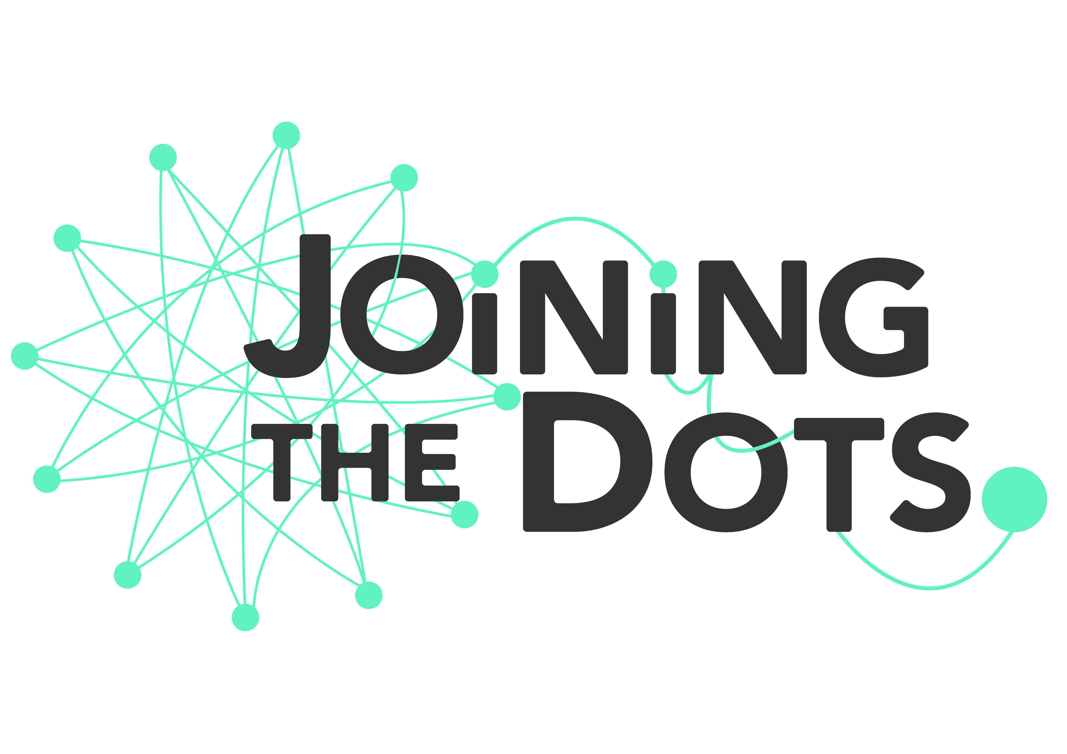
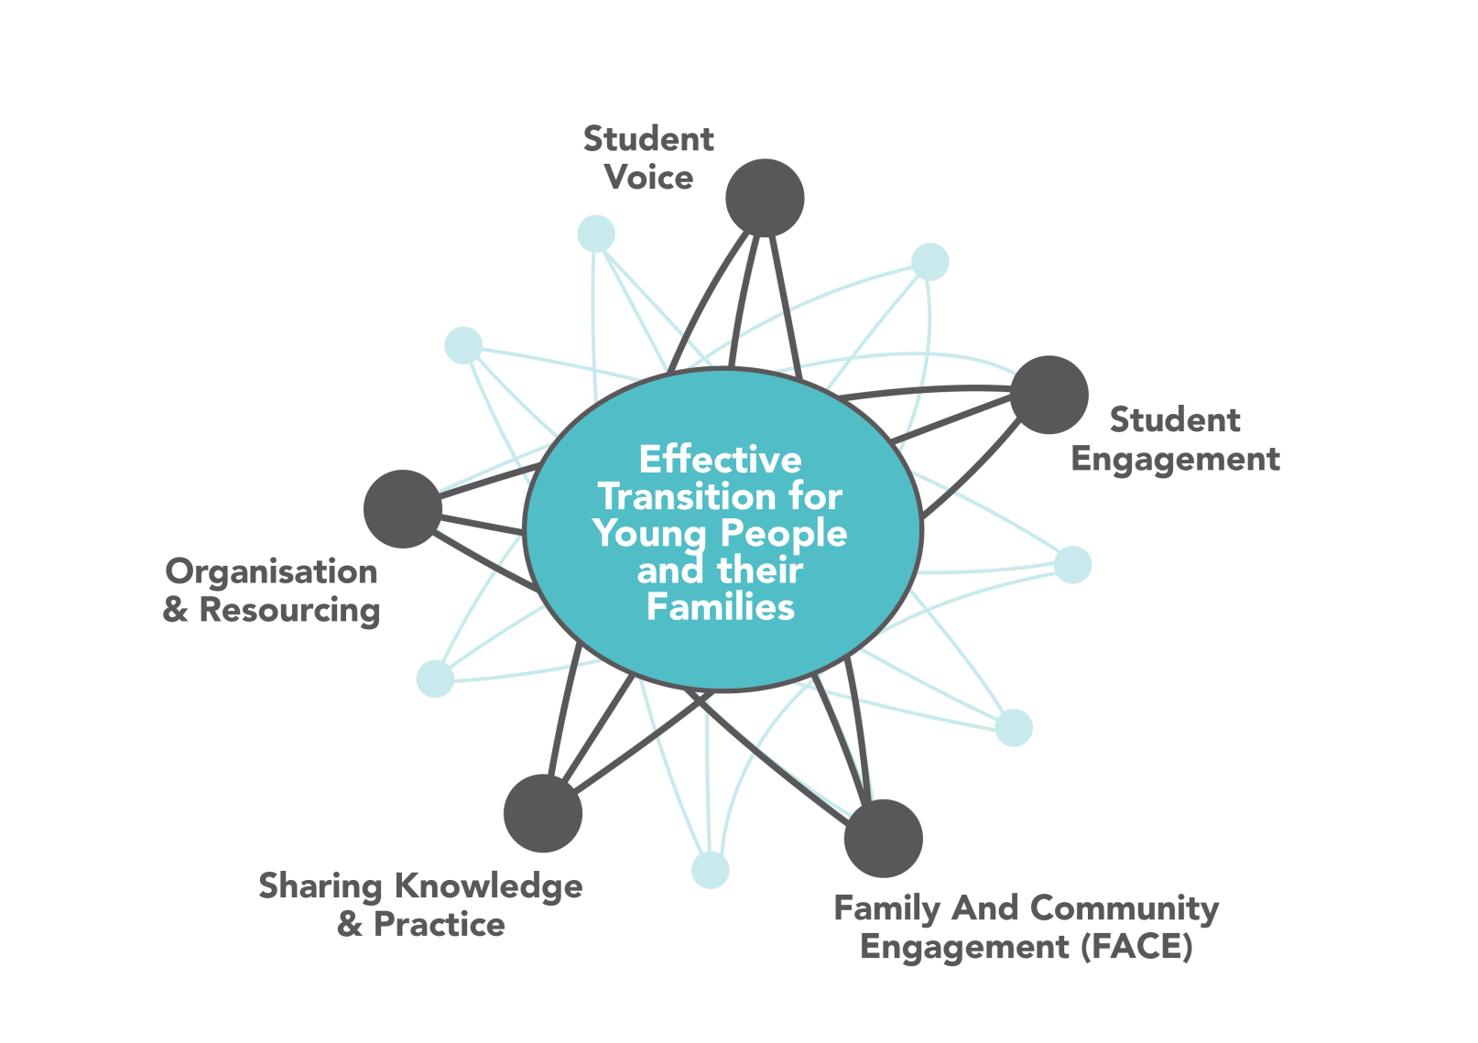
Joining the Dots Transition Model
In supporting an effective transition to secondary school (Year 4 – Year 9), educators, wellbeing and other key staff, together with community agency workers, need to work collaboratively to ensure that a student and family centred approach is embedded in school policy and practice.
The Joining the Dots Project (2012-2017) culminated in the development of a model for transition. The Project identified essential elements for an effective transition and these have been distilled into five key dimensions:
- Organisation and Resourcing - Organisations involved in transition having comprehensive, embedded and well communicated transition practice, supported by appropriate structures, processes & resources

- Sharing Knowledge and Practice - Primary and secondary schools working collaboratively and cooperatively to improve the transition experience of students and their families

- Family and Community Engagement - Student learning is supported by families and the broader community working in partnership with the school

- Student Engagement (Behavioural, Emotional & Cognitive) - Students fully participating in their education. They feel a sense of belonging and connectedness to school, are intrinsically motivated and self-regulating, are well organised and socially competent

- Student Voice -Students contributing to decision making about transition and collectively influencing transition outcomes by putting forward their ideas, views and concerns, and developing resources
Primary Secondary School
Transition Model (Year 4-Year 9)

JTD Transition Model: Recommended strategies and actions by dimension
Organisation and Resourcing | Sharing Knowledge and Practice | Family and Community Engagement (FACE) | Student Engagement |  |  | Student Voice
 |  |  | Behavioural Engagement | Emotional Engagement | Cognitive Engagement
Transition Review Process implemented including the development of a comprehensive transition and engagement plan and transition improvement strategies embedded in the Annual Implementation Plan/ Annual Action Plan | Active participation in a local transition cluster/network, strengthening relationships, sharing good practice and working collaboratively on strategic actions | Learning partnerships with parents are developed and maintained | High expectations for attendance and punctuality | Every student has a strong, positive and secure relationship with at least one adult member of the school staff | Authentic student and teacher partnership in learning. A focus on project, organisation and time management skills | Student actively involved with parents/carers in exploration and choice of a good fit secondary school
Recognition by all staff of the importance of a successful transition into, through and out of the school for improved student life outcomes | Identifying, trialing, evaluating and embedding examples of good practice in own setting | Partnerships with appropriate community agencies to support staff, student and families during transition are developed and maintained | Early identification of non-attending students through clear and evident monitoring and follow up of absence | Learning environments promote positive learning & behaviour | Students are enabled to be independent, cooperative and self-regulating learners | Student feedback guides transition practice
A whole school approach with a dedicated working group and Transition Coordinator who have sufficient capacity and access to adequate additional resources | Shared professional learning sessions and reciprocal building of knowledge between, within and across primary and secondary settings | Opportunities for parents to actively contribute to school improvement | Student participation in all school activities is actively monitored and followed up on | Social skills development is integrated into the curriculum | Students know and can articulate themselves as learners and take responsibility for their own learning | Student led forums focused on transition topics and discussions
Comprehensive and embedded transition practice that encompasses the four phases and five areas of transition | Reciprocal learning visits between settings | Parent engagement in curriculum activities | Transfer of attendance information between schools/year levels/sub-schools | Transfer of individual student wellbeing information between schools/year levels/sub-schools | Transfer of individual student learning needs information between schools/year levels/sub-schools | Students reflect on and share transition experience between settings
Comprehensive transition practice developed in partnership with families & students for support of students with a disability or vulnerable to disengagement | Shared understandings of classroom operation and practice between staff in local primary and secondary schools | Support for parent engagement in home learning | Attendance meetings and improvement plans utilised | Student learning and student wellbeing teams actively work together | Students set aspirational learning goals and they self-monitor and evaluate progress | Student Action Teams focus on projects which enhance the transition experience for students
Dedicated and comprehensive transition program for students and families transitioning part way through the year | Continuity between Year 6 and 7 in curriculum and/or assessment discussed between settings | Effective home school communication on transition | Multi-disciplinary support from within and outside of the school for individual non-attending students and their families | Monitoring of the wellbeing of all transitioning students, particularly those vulnerable to disengagement | Early identification of individual student learning needs and appropriate learning support provided | Student leadership opportunities
A focus on early intervention for transitioning students and their families | Agreements about enrolment and placement protocols | Inclusive transition information and materials | Students receive school and/or community based support if specialised intervention required | Students receive school and community based support if specialised intervention required | Building primary student understanding of secondary curriculum, pedagogy and expectations | SRC is active in the organisation of and feedback about transition activities
Build capacity of staff to better support all students and families during transition, with particular focus on vulnerable students | Agreements on student information transfer protocols established | Community conversations about transition are conducted regularly | Reengagement programs utilised | Targeted interventions utilised to prevent anticipated problems, and to respond to identified needs | Flexible learning options provided | Student led media production of transition materials
Documented and well communicated transition policies and procedures | Strategic activities developed between settings providing opportunities for Years 4-6 students to experience a secondary setting | Opportunities for parents to reflect on and share their transition experience with the school | Students know who to approach within the school for support and are confident to do so |  |  | Peer support programs implemented
Ongoing evaluation and improvement of transition practice that is inclusive of all stakeholders (school, student, family and broader community) | Strategic activities developed between settings providing opportunities for Years 7-9 students to reflect on their transition journey and share this knowledge with primary students and families | Meaningful opportunities for parent education and upskilling |  | Primary student visits to experience secondary school in action | Careers and Pathways Programs that extend beyond Year 10 subject selection to Year 7 and primary school
An effective structure/process for capturing and disseminating student data to identify and support vulnerable students and their families | Strategic activities developed between settings providing opportunities for Years 7-9 families to reflect on their transition journey and share this knowledge with primary students and families | Opportunities are provided for orientation visits with students and their families for students with diverse needs |  | Secondary student and staff visits to primary schools to share information about transition and answer any questions

Additional Notes

Additional Notes

Additional Notes

